

ASSET VERIFICATION AND RECORDING TOOL KIT


Plot 31, Bukoto Street
P.O Box 7657, Kampala, Uganda
+256 (0) 39 2000216/0772525235
email: cpa@cpa.ug

www.cpa.com

August to September 2026

VERIFICATION DETAILS

NAME OF THE REGION: | WESTERN
SUB-REGION: | TOORO
Name of Local Government | NTOROKO DISTRICT
VERIFIER PARTICULARS
Full name | ZALWANGO MARIA, NASSEJJE NADIA, NABBOSA SUMAYA
Contact/ email and Telephone | 0751977570/ 0754884004/ 0708098456
Supervisor/ Sub team leader
Name | DEPAUL MBONIGABA
Contact | 0788483159
Date of submission

SCHOOL VERIFICATION CHECKLIST

SCHOOL INTERVIEW/DISCUSSION GUIDE

Name of school: KIBUKU SEED SECONDARY SCHOOL

1a | Does the Facility have a record of all assets provided under UgIFT.  (Obtain a record and verify if it has the costs and numbers supplied
1b | If Not ask how many were supplied and when.

2 | How does this facility Maintain (repair/service/replace) the assets provided under Ugift

3 | Does the facility take regular record about functionality/ or breakdown of the assets provided?  Nonfunctional/ working, and reasons for non-functionality.

4 | How has the UgIFT support helped in service delivery in the area, any issues, challenges and any recommendations for better program implementation.

PROCEED TO VERIFICATION AFTER THIS DISCUSSION

SCHOOL FURNITURE
(School Desks, Office chairs, Laboratory stools, Book shelves)

Name of LG: NTOROKO DISTRICT Name of SCHOOL: NOMBE SEED SECONDARY SCHOOL

Equipment/ Item | Department | Asset Number | Item  Description | Life in Months | Tag Number ( engrave no.) | Date Of Pur | Date Placed In Service | Recoverable cost | Cost | Acc Dep Cost | Net Book Value | Ytd Deprn | Equipment status | Remarks

ICT ITEMS TO VERIFY
(Desktop Computer, Server Processor, Network Switch 24 Port, Multipurpose Printer, UPS, Projector, Air Conditioners, Server, CCTV Camera)

Name of LG…………………………………………………………………………… Name of SCHOOL………………………….………………………………………

Equipment/ Item | Department | Asset Number | Item  Description | Life in Months | Tag Number ( engrave no.) | Date Of Pur | Date Placed In Service | Recoverable cost | Cost | Acc Dep Cost | Net Book Value | Ytd Deprn | Equipment status | Remarks
ICT ITEMS |  |  |  |  |  |  |  |  |  |  |  |  |  | They never received any ICT items

BUILDINGS TO VERIFY
(Non- Residential and Residential, Kitchen, Toilets/Pit latrine Water tanks, Fences etc.)

Name of LG…………………………………………………………………………… Name of SCHOOL………………………….………………………………………

Equipment/ Item | Department | Asset Number | Item  Description | Life in Months | Tag Number ( engrave no.) | Date Of Pur | Date Placed In Service | Recoverable cost | Cost | Acc Dep Cost | Net Book Value | Ytd Deprn | Equipment status | Remarks
Non residential | Education |  | Under construction |  |  |  |  |  |  |  |  |  | Good condition | They are 4 but not in use
Residential | Education |  | Under construction |  |  |  |  |  |  |  |  |  | Good condition | They are not yet used  They are 3 in number.
Kitchen | Education |  | Under construction |  |  |  |  |  |  |  |  |  | Good condition | They are not yet used
Toilets | Education |  |  |  |  |  |  |  |  |  |  |  |  | They are 3 in number not constructed
Pit latrine | Education |  | Under construction |  |  |  |  |  |  |  |  |  | Good condition | Not yet used they are 4 in number.
Water tanks | Education |  | They are black in colour |  |  |  |  |  |  |  |  |  | One is faulty and two are working. | No yet received.
 |  |  | Under construction |  |  |  |  |  |  |  |  |  | Good condition | Not yet in use
Fence |  |  |  |  |  |  |  |  |  |  |  |  |  | Not constructed.
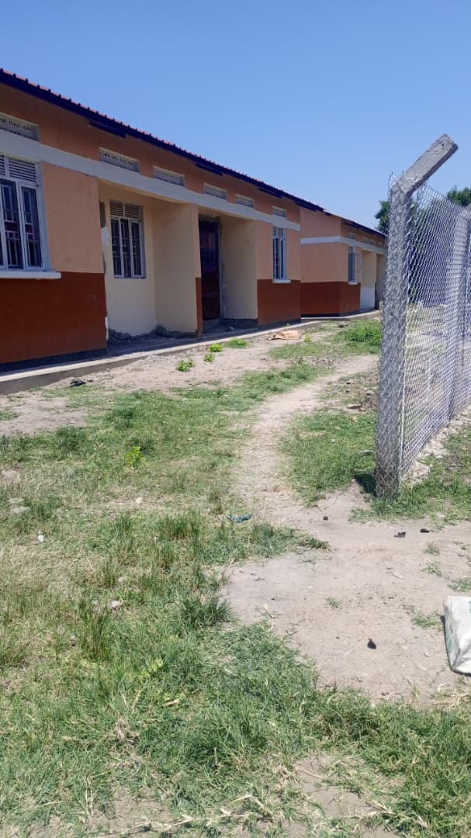
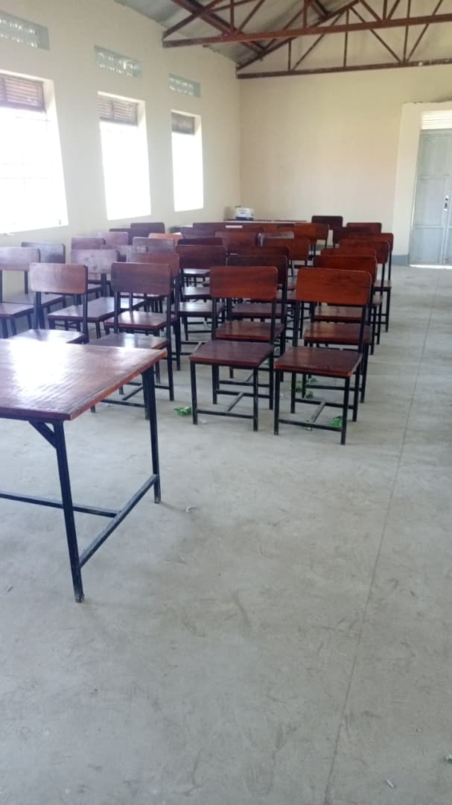

Office chairs Un finished staff quarters

